Rodrigo Luzuriaga

CISD 40

3/1/18

Chapter 1 - Problems

1. **How many records does the file contain? How many fields are there per record?**
   1. The file contains 7 records, and 5 Fields in each record.
2. **What problem would you encounter if you wanted to produce a listing by city? How would you solve this problem by altering the file structure?**
   1. 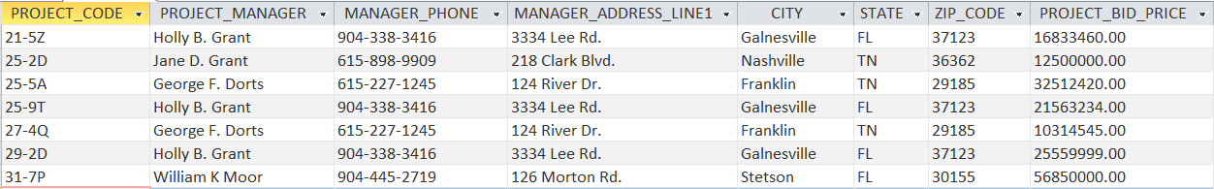The MANAGER_ADDRESS is not broken up by address line, city, state, and zip so you cannot create a listing by city easily. You would need to modify the table to look like this
3. **If you wanted to produce a listing of the file contents by last name, area code, city, state, or zip code, how would you alter the file structure?**
   1. Create a new table for PROJECT_MANAGER that has PROJECT_MANAGER_ID, FIRST_NAME, MIDDLE_INITIAL, LAST_NAME, PHONE_NUMBER, ADDRESS_LINE, CITY, STATE, and ZIP_CODE that looks like the one bellow.
4. **What data redundancies do you detect? How could those redundancies lead to anomalies?**
   1. Project managers are in that table multiple times, so there could be issues with the phone number, or address being wrong on one of those records. So those project managers should only appear once (like the table above).
5. **Identify and discuss the serious data redundancy problems exhibited by the file structure shown in Figure P1.5.**
   1. There are different job charges per hour for the same job code. There also are multiple instances of the same EMP_NAME.